ỦY BAN NHÂN DÂN TP.HCM CỘNG HÒA XÃ HỘI CHỦ NGHĨA VIỆT NAM
TRƯỜNG CAO ĐẲNG LÝ TỰ TRỌNG TPHCM Độc lập – Tự do – Hạnh phúc
********** ******

PHIẾU TRẢ LỜI TRẮC NGHIỆM

Tên: ____________________________________ Đề thi số: 02
Lớp: ___________ Ngày thi: _____________

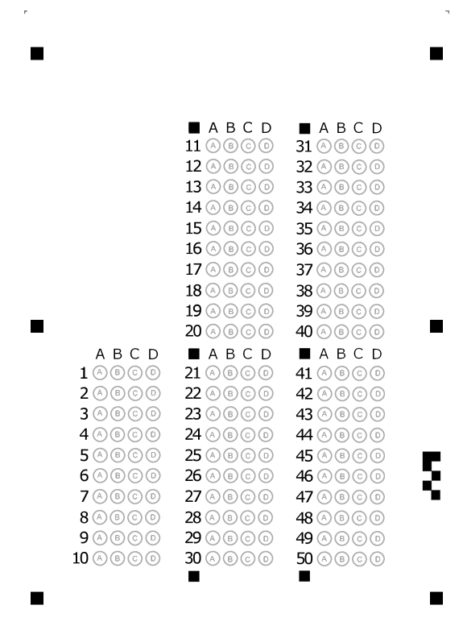

ỦY BAN NHÂN DÂN TP.HCM CỘNG HÒA XÃ HỘI CHỦ NGHĨA VIỆT NAM
TRƯỜNG CAO ĐẲNG LÝ TỰ TRỌNG TPHCM Độc lập – Tự do – Hạnh phúc
********** ******
ĐỀ 2
ĐỀ THI GIỮA HỌC PHẦN LÝ THUYẾT
BẬC ĐÀO TẠO : CAO ĐẲNG
HỌC PHẦN : ANH VĂN
HỌC KỲ : I NĂM HỌC: 2017 - 2018
Lớp: 17C1-KML1, CNO8 Ngày thi: 21 + 23/ 11 / 2017
Thời gian thi : 60 phút
(Sinh viên không được sử dụng tài liệu trong khi làm bài. Sinh viên trả lời vào PHIẾU TRẢ LỜI TRẮC NGHIỆM)
(Đề thi gồm 50 câu. Mỗi câu trả lời đúng được 0.2 điểm)
------------------------------------------------
A. LISTENING
Part I: Listen to the conversations. Choose the names.
1. A. Damien B. David C. Dakid D. Damin
2. A. Jackson B. John C. Johnson D. Jelson
3. A. Robs B. Bob C. Tob D. Cob
4. A. Michelle B. Mary C. Mario D. Marcia
5. A. Smith B. Smid C. Smit D. Schmidt
B. READING
Part II: Incomplete Sentences: Choose the word or phrase that best complete the sentence.
6. I broke the plate ________ was a wedding present.
A. who B. whom C. whose D. that
7. The Queen fired the chef ________ we had met.
A. who B. which C. that D. whose
8. Jill ate the sandwich ________ had tomato and cheese inside.
A. which B. whom C. whose D. who
9. He told me the places and people ________ he had seen in London.
A. which B. who C. whom D. that
10. The book ________ about Japanese culture is very interesting.
A. where B. whom C. who D. that
11. He likes films ________ come from Asia.
A. where B. which C. who D. whom
12. The chocolate ________ we bought last week was very old.
A. that B. where C. whose D. who
13. The girl ________ I met yesterday is on TV tonight.
A. which B. who C. whom D. whose
14. That’s the boy ________ mother works in the post office.
A. which B. whose C. whom D. where
15. They would like to live in a country ______ there is plenty of snow in winter.
A. which B. where C. when D. that

16. Mothers always worry ______ their children.
A. in B. on C. about D. at
17. I’m fed up of waiting ______ spring.
A. on B. for C. in D. with
18. Which university you go to depends ______ your exam results.
A. on B. in C. at D. for
19. When she arrived ______ the pub, it was already closed.
A. on B. for C. about D. at
20. That's a good idea. Why didn't you think _____ it?
A. at B. on C. of D. to
21. My birthday is _____ May 5th.
A. on B. in C. at D. for
22. I like swimming _____ summer.
A. on B. at C. in D. about
23. For the last few days I haven’t been able to sleep _____ night.
A. in B. on C. at D. for
24. I’m so worried _____ my sister who is ill.
A. for B. about C. in D. with
25. He was standing _____ the middle of the room.
A. for B. on C. at D. in
26. I ran to the shop _____ I was in a hurry.
A. although B. but C. so D. because
27. They didn’t want to dance _____ they left the club early.
A. so B. because C. although D. but
28. We didn’t go anywhere special, _____ we had a wonderful evening.
A. but B. althought C. after that D. then
29. It was a sad story _____ it had a happy ending.
A. because B. so C. although D. then
30. We drove along the street very slowly _____ we couldn’t find the house.
A. after that B. but C. although D. then
31. I’m busy at the moment. I _______ on the computer.
A. work B. worked C. am working D. working
32. I haven’t seen Kate _______ Christmas.
A. for B. never C. ever D. since
33. Every time Parkas sees a movie made in India, he _______ homesick
A. feels B. felt C. will have left D. is feeling
34. Now my sister _____ a bicycle of her own.
A. is having B. are having C. has D. had
35. My brother _____ out at weekend.
A. doesn’t usually go B. does usually not go C. doesn’t usually goes D. doesn’t goes
36. Anita _____ very hard at the moment.
A. is studying B. studies C. studied D. has studied
37. Please don’t make so much noise. I ____.
A. studying B. study C. am studying D. studied
38. He ____ up at five every morning.
A. is getting B. got C. was getting D. gets
39. He usually ____ her at weekend but now he ____ in bed because of his severe illness.
A. visits/stays B. visits/ is staying C. visited/stays D. visits/ staying
40. ____ you sometimes ____ out with friends?
A. Do/go B. Are/going C. Have/gone D. Did/go
41. He has been selling motorcycles _____
A. ten years ago B. since ten years C. for ten years ago D. for ten years
42. Spring _____ winter
A. follows B. is following C. will follow D. has followed
43. Hurry! The train _____. I don’t want to miss it.
A. comes B. is coming C. came D. has come
44. Jane _______ just a few minutes ago.
A. left B. has left C. leaves D. had left
45. We _____ English this time last week
A. learned B. were learning C. have learned D. had learned
46. When I entered the room, everyone _______.
A. has been dancing B. was dancing C. had danced D. danced
47. We were asked not to disturb the baby because he ____.
A. is sleeping B. slept C. sleeping D. was sleeping
48. We have been living here _______ 1990
A. for B. from C. since D. during
49. When he came, _____
A. I was watching TV C. I am watching TV
B. I watched TV D. I have watched TV
50. He ____ for London one year ago.
A. leaves B. has left C. left D. had left
The End of the Test

Trưởng khoa Giáo viên soạn đề

Trần Kim Thu Liễu Đinh Trần Phương Thảo

